Project Design Phase-II
Technology Stack (Architecture & Stack)

Date | 03 october 2026
Team ID | SWTID-2026-4339
Project Name | Streamlining IT Procurement: Automating Standard Laptop Orders with Flow Designer
Maximum Marks | 4 Marks

Technical Architecture:
The Deliverable shall include the architectural diagram as below and the information as per the table1 & table 2
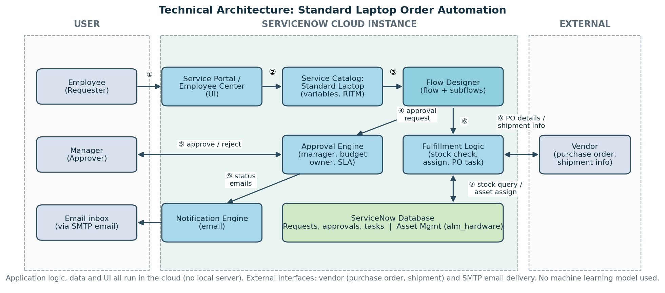

Table-1 : Components & Technologies:
S.No | Component | Description | Technology
 | User Interface | Employees request laptops and track status in the Service Portal; managers approve from email or the portal. | ServiceNow Service Portal / Employee Center (HTML, CSS, JavaScript, AngularJS widgets)
 | Application Logic-1 | Request handling: the Standard Laptop catalog item with variables creates the request (RITM) and triggers the flow. | ServiceNow Service Catalog, Flow Designer trigger
 | Application Logic-2 | Approval logic: manager approval, extra approval above the cost threshold, SLA reminders and rejection handling. | Flow Designer (Ask for Approval action, subflows)
 | Application Logic-3 | Fulfillment logic: stock check, asset assignment, purchase order task when out of stock, and request closure. | Flow Designer actions (Look Up Record, Update Record, Create Task), server-side JavaScript
 | Database | Stores requests, approvals, tasks, users and departments. | ServiceNow platform relational database (sc_req_item, sysapproval_approver)
 | Cloud Database | Asset records and stock levels used for the inventory check. | ServiceNow Asset Management (alm_hardware) on the cloud instance
 | File Storage | Attachments such as quotes and invoices stored on requests. | ServiceNow attachment storage (sys_attachment)
 | External API-1 | Email notifications to the requester and approvers at approval, shipment and delivery. | ServiceNow Notifications with SMTP email
 | External API-2 | Sends purchase order details to the vendor and receives shipment information. | Vendor integration via REST API or email (IntegrationHub, optional)
 | Machine Learning Model | Not used. The solution is rule-based workflow automation. | Not applicable
 | Infrastructure (Server / Cloud) | Application deployment on Cloud  Local Server Configuration: Not required  Cloud Server Configuration: ServiceNow hosted instance | ServiceNow Cloud (hosted instance)

Table-2: Application Characteristics:
S.No | Characteristics | Description | Technology
 | Open-Source Frameworks | Open-source libraries used by the Service Portal front end. | AngularJS, Bootstrap
 | Security Implementations | Role-based access control and ACLs, approvals only by the assigned approver, audit trail of every action, encrypted communication. | ServiceNow roles and ACLs, HTTPS/TLS, audit logs
 | Scalable Architecture | Multi-tier cloud platform. Flow logic is split into reusable subflows and actions, so new catalog items can be added without rebuilding. | ServiceNow platform (3-tier), Flow Designer subflows
 | Availability | Hosted on ServiceNow cloud infrastructure with platform-level redundancy and failover. | ServiceNow cloud hosting
 | Performance | Event-driven flow with asynchronous notifications and indexed lookups on the asset table. | Flow Designer, ServiceNow event queue, database indexes

References:
https://c4model.com/
https://developer.ibm.com/patterns/online-order-processing-system-during-pandemic/
https://www.ibm.com/cloud/architecture
https://aws.amazon.com/architecture
https://medium.com/the-internal-startup/how-to-draw-useful-technical-architecture-diagrams-2d20c9fda90d

